Healing Circle Natural Health


Confidential Client Information and Health History

Full Name: __________________________________________________________________
Address: ___________________________City:______________ State: _____Zip_________
DOB________ Age _________Phone: H_________________W_________________Cell_________________
Email: ________________________________________ How did you hear about us? ________________
Referred by: ______________________________ Marital Status: ______________________
Married: ______ Separated:_______Divorced:_______Widowed:_______Single:______ Partnership__________
Live with: Spouse______ Partner_______Parents________Children_______Friends_______Alone_________
Emergency Contact: ____________________________Phone: ________________________
Employer: __________________________ Occupation: _____________________________
------------------------------------------------------General Health------------------------------------------------------------
Describe your general state of health: Excellent Good Fair Poor
Current Health Concerns: What do you hope to accomplish with today’s visit? Please list in order of importance/severity: 1._________________________________________ 2.______________________________________
3._________________________________________ 4.______________________________________
5._________________________________________ 6.______________________________________
What other therapies are you currently using? (Please check all that apply)
Chiropractic ___ Physical Therapy ___ Massage _____Acupuncture ____ Colon therapy _____ Psychotherapy ___
Other: ________________________________________________________________________________________
Are you currently under care of a medical doctor, alternative health practitioner or chiropractor? _______________
Please name: ___________________________________________________________________________________
Describe any surgeries, hospitalizations, accidents or injuries you have had:
Less than 5 years ago: _______________________________________________________________________
More than 5 years ago: _______________________________________________________________________
What kind of care did you receive for your accident/injury? __________________________________________
Do you feel you have recovered from these events? ________________________________________________
Do you have any chronic, ongoing pain, tingling, numbness that you deal with on a regular basis? ___________
Please explain: _____________________________________________________________________________ __________________________________________________________________________________________
Describe what activities cause this pain or make it worse: ___________________________________________
Please rate your level of stress: (low) 1 2 3 4 5 6 7 8 9 10 (high)
The main stressor is: Financial Job related Marriage Health Interpersonal Family Spiritual Other:
Do you exercise regularly? Yes/No Type: ________________________ Frequency:_______________________
How many hours do you sleep per night? ________ How many times do you wake in the night?________
Do you wake feeling rested in the morning? ________
How many hours do you work each day? _________ How many breaks do you take in a day? ___________
In your job are you mainly: Sitting At a computer Standing Driving Bending Lifting Other?
What do you do to deal with stress?: ________________________________________________________________
When was your last vacation?: ____________________________________________________________________
How much change are you willing to make at this time in your life for improving your health?
Minimal Some Complete
Do you have a spiritual or religious practice? _______________________
Do you Smoke? _________ Drink Caffeine? ________ Alcohol? _________ Rec. Drugs? ________
Please indicate how much: ____________________________________________________________________________
Please list any vitamins, herbs or natural supplements you are taking, please explain what they are for: ____________________________________________________________________________________________________________________________________________________________________________________________________
Please list any prescription or over the counter medications you are taking, please explain what they are for:
____________________________________________________________________________________________________________________________________________________________________________________________________
How many times have you been treated with antibiotics in the past 5 years? _______________
Did you have frequent or recurrent ear infections or sinus problems as a child? ___________
Do you consume any of the following: milk or milk products meat Soda: diet/regular coffee
Antacids salt laxatives diet pills fast food tea artificial sweetener organic food
Are you a Vegetarian?_______ Vegan:________Macrobiotic:________ Fruitarian:___________ Raw: ____________
Describe your basic diet:
Breakfast: _____________________________________________________________________________________
Lunch:________________________________________________________________________________________
Dinner: _______________________________________________________________________________________
Describe your appetite:____________________________________________________________________________
Food cravings: ___________________________________________________________________________________
Do you consider yourself: Overweight? Underweight? Just right?
Do you tend towards diarrhea or constipation? ______________________ Alternating? _________________
How many bowel movements do you have per day? _________ How often? Every day Every other day Weekly

----------------------------------------------------------------------------------------
Women: Are you pregnant?____________ Menopausal?_______________Perimenopausal?______________
If you are still menstruating what kind of birth control do you use? __________________________
How many days in your cycle? __________ How long does the flow last?________________
Do you experience: Cramping? PMS? Water Retention? Headaches? Mood Changes? Other?
Are you taking HRT? Yes/No Bio Identical? Yes/No
--------------------------------------------------------------------------------------

Are there any other health concerns you wish to discuss today? _____ If yes, please describe: _______________________________________________________________________________________________
_______________________________________________________________________________________________
_______________________________________________________________________________________________
If you are experiencing pain, tingling or numbness, please indicate on the drawing below

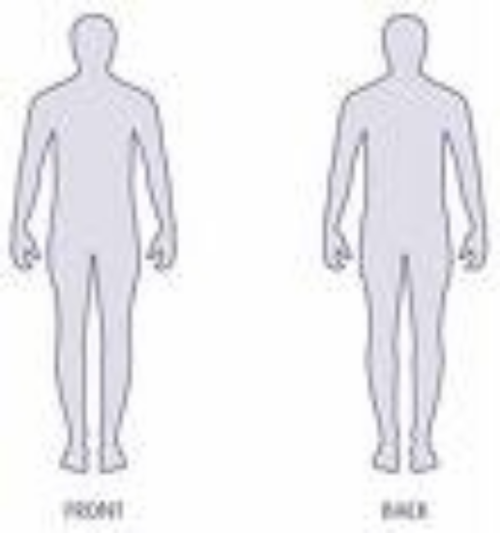
Front Back

Circle the severity of your pain (0 = no pain, 10 = worst pain ever)
1 2 3 4 5 6 7 8 9 10

Are you currently experiencing any of the following conditions?
Flu or cold______Inflammation________Fever________Infection________Contagious Disease__________
Please circle any the following conditions below that affect you now or that you have experienced in the last 15 years?

Musculoskeletal
Fibromyalgia
Spasms/Cramps
Sprains/Strains
Osteoporosis
Postural Deviations
Gout
Osteoarthritis/Rheumatoid Arthritis
TMJ dysfunction
Cysts
Bursitis
Plantar Fascitis
Tendonitis
Torticollis
Whiplash
Carpal tunnel Syndrome
Sciatica
Thoracic Outlet Syndrome
Headache
Migraines
Leg Pain
Arm/Shoulder pain
Low Back Pain
Mid Back Pain
Hip Pain
Other

Respiratory
Pneumonia
Sinusitis
Asthma
Trouble Breathing
Dizziness
Other

Circulatory
Anemia
Hemophilia
Hypertension (high blood pressure)
Low Blood Pressure
Raynaud’s Disease
Varicose Veins
Heart Condition
Blood Clots/Phlebitis
Diabetes
Other

Digestive
Ulcers
Irritable Bowel Syndrome
Colitis
Gallstones
Hepatitis A, B, C
Crohn’s Disease
Diarrhea
Gas/Bloating
Acid Reflux
GERD
Indigestion
Other

Skin
Fungal Infections/Acne
Impetigo
Dermatitis/Eczema
Psoriasis
Open Wound or Sore
Rashes
Dry Skin
Warts/Moles
Athletes Foot
Herpes
Plantar warts
Shingles

Nervous System
ALS
Multiple Sclerosis
Parkinson’s disease
Bell’s palsy
Neuritis
Spinal Cord Injury
Stroke
Trigeminal Neuralgia
Seizure Disorder
Numbness/Tingling/Twitching

Other
Insomnia
Depression
Bi-Polar (manic-depression)
Sleep Apnea
Anxiety/Panic Attacks
PMS
Physical/Emotional Abuse
Grief Process
Cancer
Substance Abuse
Pregnancy
Uterine Fibroid
Endometriosis
Chronic Fatigue
HIV/AIDS
Lupus
Lyme’s Disease
Kidney Disease
Bladder Infection
Postoperative Situation
Edema
Sore throat
Eating Disorder
Hormone Replacement
Other

The above information is accurate and true to the best of my knowledge. I understand that Kathy Gruver is not a medical doctor and does not diagnose disease, prescribe medications, or manipulate bones. I understand that this information is confidential and will not be shared with another individual with out my written consent. I further understand that naturopathy is not a substitute for medical attention or examination. I take responsibility for alerting my practitioner to any physical, mental or emotional changes that occur with my health. I also understand that cancelled or missed appointments without 24 hours notice (medical emergencies excluded) will be charged in full for the price of the missed session.

Signature: _______________________________________________ Date: ______________

For Consultant Use Only

Ph reading:
Posture:
Body fat:
Cholesterol?
Blood pressure

Iridology:

Observations:

Recommendations:

Rx side effects:

Sources consulted?

Follow up:

